3/6/2024

Group 6 Project 1 Meeting 1

Attended: Prithibi, Sabrina, Zack, Auyon

Time of meeting: 10:30 PM

* Discussed the theme of the JDBC
  + Bikini Bottom
  + Overwatch
  + Valorant
  + Minecraft
  + Pokemon (First 151)
    - Group decided on doing the first 151 Pokemon
* Zack and Sabrina finished initializing Java and Git and VSCode on their systems
* Group decided to create a UML chart on Lucid chart to detail our thought process.
* Zack and Prithibi unavailable all day Sunday due to midterm exams
* Zack and Sabrina will attend office hour on 3/7/2024 to ask follow up questions about project 1

Lucid chart finish Thursday night

Office hour Thursday

3/10/2024

Group 6 Project 1 Meeting 2

Attended: Prithibi, Sabrina, Zack, Auyon

Time of meeting: 10:30 PM

* Zack was able to fix the JDBC and get it to work properly.
* Group decided that we would make 3 databases based on Pokemon. Each database will represent a different generation of Pokemon.
* Sabrina completed Lucid Chart conceptual diagram of what the database should look like.
* Prithibi will help Auyon, Sabrina, and Zack set up docker and azure data studios on their laptops in preparation for the midterm.

3/12/2024

Group 6 Project 1 Meeting 3

Attended: Prithibi, Sabrina, Zack, Auyon

Time of meeting: 11:00PM

* Prithibi was able to help Zack, Auyon, and Sabrina set up docker and azure studio on their laptops.
* Group brain stormed how we would create the 3 Pokemon databases, and how we would initialize it (discussed how we were going to combine all of other data, and what was the most efficient way to do so.)

3/20/2024

Group 6 Project 1 Meeting 4

Attended: Prithibi, Sabrina, Zack, Auyon

Time of meeting: 10:00 PM

* Group was finally ready to start creating the 3 Pokemon Database.
* Group followed Auyon’s initialization:

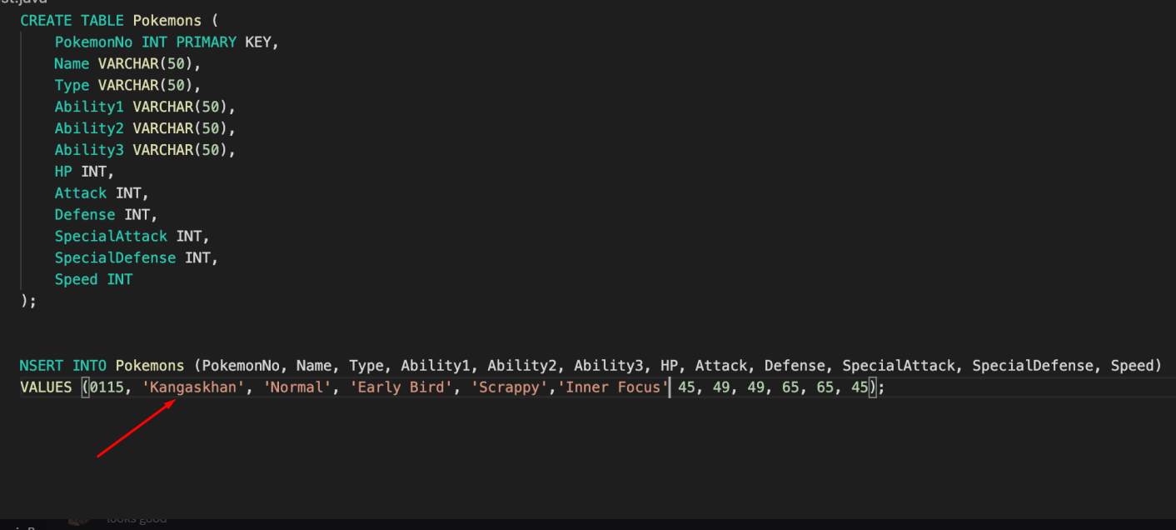

* Each member was assigned to do ~30 different entries per each generation, so around 100 entries each.

3/23/2024

Group 6 Project 1 Meeting 5

Attended: Prithibi, Sabrina, Zack, Auyon

Time of meeting: 10:00 AM

* Group 6 met early in the morning to start creating their queries for Project 1.
* 7 of the complex queries would come from the Pokemon databases, and 13 of the medium queries would come from Northwinds/AdventureWorks.
* Meeting ended off with Group 6 creating all of the 7 complex queries, but still need to create the 13 medium queries.
* Group 6 needed to also select their top 3 and worst 3 queries.
* Lastly, Group 6 updated the JDBC so that the result fed into it would be displayed in a GUI, rather than in the console.

3/24/2024

Group 6 Project 1 Meeting 5

Attended: Prithibi, Sabrina, Zack, Auyon

Time of meeting: 12:00 PM

* Group 6 met at noon to finalize anything they had left for Project 1, and to start the recording.
* All files were uploaded to Github.